JUAN LUIS FLORES G

To run program: python camellie.py

Error Test with Error:

**No ‘program’ symbol**

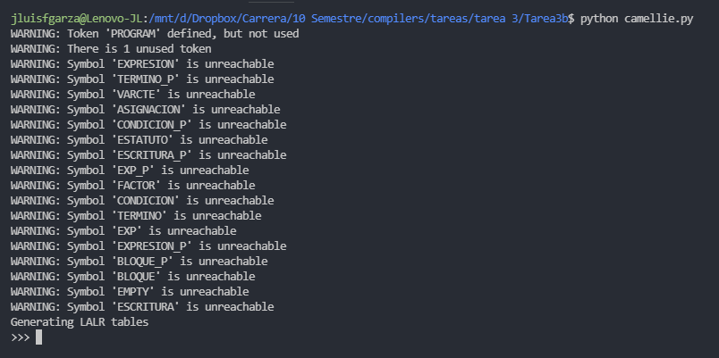

Working Test

